
Ceremonial for Reception and Profession

In the Third Order of Penance of Saint Dominic

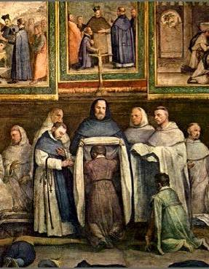

Ceremonial for Reception and Profession
In the Third Order of Penance of Saint Dominic

The priest, dressed in the Cappa and white stole (or surplice and stole, if he be a secular priest), goes to the altar with a server carrying a candle and holy water. Two candles should be lighted on the altar, and the scapular to be blessed should be placed on the Epistle Side. The postulant(s) and novice(s) kneel, and the priest asks:

Priest: What do you seek?
Novice and Postulant: God’s mercy and yours.

Now the priest may, if he wishes, give a short exhortation on the excellence or the duties of the Third Order; then, returning to the Epistle side of the altar, he blesses the habit as follows:

V. Ostende nobis, Domine, misericordiam tuam.  R. Et salutare tuum da nobis.  V. Dominus vobiscum.  R. Et cum spiritu tuo.  OREMUS.  Domine Jesu Christe, qui tegimen mortalitatis nostrae induere dignatus es, obsecramus immensae largitatis tuae abundantiam, ut hoc genus vestimentorum, quod sancti Patres ad innocentiae et humilitatis indicium ferre sanxerunt, ita benedicere digneris, ut qui() hoc usus fuerit te induere mereatur, Christum Dominum Nostrum.  R. Amen. | V. Show us thy mercy, O Lord.  R. And grant us thy salvation.  V. The Lord be with you.  R. And with thy spirit.  Let us pray.  O Lord Jesus Christ, who hast deigned to put on the garment of our mortality, we beseech that in the abundance of Thy immense generosity Thou wouldst deign to bless this kind of garment, which the holy Fathers adopted to be worn as a sign of innocence and humility, so that he/she who wears it may be made worthy to put on Thee, Our Lord Christ.  R. Amen.
The priest here sprinkles the habit(s), and then the postulants, with holy water, saying:
Aspergat etiam te Dominus, nostris jam nunc vestibus induendum hyssopo, et munderis(emini); quatenus mundatus et super nivem in mentibus dealbatus, sic nostra forinsecus gerere valeas indumenta; ut bonorum tuorum operum exemplo, fias omnibus quibuscum conversaberis, odor vitae in vitam, ne forte, per mala opera tua, vitperetur ministerium nostrum.  R. Amen. | May the Lord also sprinkle you with hyssop, who are about to be clothed with our garments, and may you be so cleansed that, clean and whiter than snow in mind, you may so avail in the outward bearing of our garb as to be, by the example of your good works, the odour of life unto life to all with whom you will hold converse, lest perhaps, by your evil works, our ministry be blamed.  R. Amen.

The priest gives the postulant and/or novice a lighted candle. Then, kneeling on the last step of the altar, he intones the Veni Creator; he rises (together with everyone else) after the first stanza. The chant may be sung by alternating choirs.

VENI, Creator Spiritus,  mentes tuorum visita,  imple superna gratia  quae tu creasti pectora.  Qui Paraclitus diceris,  donum Dei altissimi,  fons vivus, ignis, caritas,  et spiritalis unctio.  Tu, septiformis munere,  dextrae Dei tu digitus,  Tu rite promissum Patris,  sermone ditans guttura.  Accende lumen sensibus:  infunde amorem cordibus:  infirma nostri corporis  virtute firmans perpeti.  Hostem repellas longius,  pacemque dones protinus:  ductore sic te praevio  vitemus omne noxium.  Per te sciamus da Patrem,  noscamus atque Filium;  Teque utriusque Spiritum  credamus omni tempore.  Sit laus Patri cum Filio,  Sancto simul Paraclito,  nobisque mittat Filius  charisma Sancti Spiritus.  Amen. | COME, Holy Ghost, Creator blest,  and in our souls take up Thy rest;  come with Thy grace and heavenly aid  to fill the hearts which Thou hast made.  O comforter, to Thee we cry,  O heavenly gift of God Most High,  O fount of life and fire of love,  and sweet anointing from above.  Thou in Thy sevenfold gifts art known;  Thou, finger of God's hand we own;  The promise of the Father, Thou  Who dost the tongue with power imbue.  Kindle our senses from above,  and make our hearts o'erflow with love;  with patience firm and virtue high  the weakness of our flesh supply.  Far from us drive the foe we dread  and grant to us Thy peace instead;  and so shall we, with Thee for guide,  avoid all harm our path beside.  Oh, may Thy grace on us bestow  the Father and the Son to know;  and Thee, through endless times confessed,  of both the eternal Spirit blest.  Now to the Father and the Son,  Who rose from death, be glory given,  with Thou, O Holy Comforter,  henceforth by all in earth and heaven.  Amen.

V. Emítte Spíritum túum et creabúntur.  R. Et renovábis fáciem térrae.  V. Ora pro nobis, beate Pater Dominice.  R. Ut digni efficiamur promissionibus Christi.  V. Laetamini in Domino et exultate, justi.  R. Et gloriamini, omnes recti corde.  V. Salvum fac servum tuum [ancilla tua/servos tuos].  R. Deus meus, sperantem in te  V. Dominus vobiscum.  R. Et cum spiritu tuo.  Oremus.  Deus, qui corda fidelium Sancti Spiritus illustratione docuisti: da nobis in eodem Spiritu recta sapere; et de eius semper consolatione gaudere.  For the postulant(s).  Concede, quaesumus, omnipotens Deus, ut famuli tui qui peccatorum suorum pondere premitur, his indutus poenitentiae vestimentis beati Dominici Confessoris tui Patris nostri patrocinium subleventur.  Concede, quaesumus, omnipotens Deus, ut ad meliorem vitam Sanctorum Ordinis nostri exempla hunc famulum tuum succurrant et provocent, quatenus, quorum sacram poenitentiae vestem gerere cupit etiam virtutum actiones imitetur.  For the novice(s).  Concede, quaesumus, omnipotens Deus, ut famuli tui qui peccatorum suorum pondere premitur, hanc poenitentiae Regulam professurus beati Dominici Confessoris tui Patris nostri patrocinium subleventur.  Concede, quaesumus, omnipotens Deus, ut ad meliorem vitam Sanctorum Ordinis nostri exempla hunc famulum tuum succurrant et provocent, quatenus poenitentiae regulam quam professurus est valeat eorum meritis et intercessionibus adimplere.  Praetende Domine famulo tuo dexteram caelestis auxilii, ut te toto corde perquirat et quae digne postulat assequatur.  Per Christum Dominum nostrum.  R. Amen. | V. Send forth Thy Spirit, and they shall be created.  R. And Thou shalt renew the face of the earth.  V. Pray for us, O holy Father Dominic.  R. That we may be made worthy of the promises of Christ.  V. Rejoice in the Lord and exult, o ye just.  R. And glory, all ye of upright heart.  V. Save your servant (handmaid/-s)  R. O my God, who put their trust in Thee.  V. The Lord be with you.  R. And with thy spirit.  Let us pray.  O God, Who didst instruct the hearts of the faithful by the light of the Holy Spirit, grant us in the same Spirit to relish what is right and ever to rejoice in His consolation.  Grant, we beseech Thee, almighty God, that thy servant(s) who is (are) weighed down by the burden of (his) sins may, being clothed in these garments of penance, be lifted up by the patronage of blessed Dominic, our Father, thy Confessor.  Grant, we beseech Thee, almighty God, that the example of the Saints of our Order may help and inspire this thy servant (handmaid) to a better life, so that (he) who desires to wear their sacred habit of penance may also imitate their virtuous actions.  Grant, we beseech Thee, almighty God, that thy servant(s) who is (are) weighed down by the burden of (his) sins may, being about to profess this rule of penance, be lifted up by the patronage of blessed Dominic, our Father, thy Confessor.  Grant, we beseech Thee, almighty God, that the example of the Saints of our Order may help and inspire this thy servant (handmaid) to a better life, so that (he) who is about to profess their rule of penance may be able to fulfil it by their merits and intercession.  Stretch forth, O Lord, to thy servant(s) the right hand of heavenly assistance, so that (he) may seek Thee with his whole heart and obtain what (he) worthily asks for, through Christ, our Lord.  R. Amen.

At the end of the prayers, priest gives to the postulant (to each separately, if there be several), the scapular, saying:
Accipe sancti Ordinis nostri Scapulare, potissimam praedicatoriae nostrae vestis partem, maternum de caelo Beatissimae Virginis Mariae in nos amoris pignus; sub cujus pennis et scapula erit tibi umbraculum ab aestu, et ab omnibus tam corporis quam animae periculis in morte propugnaculum et munimen.  R. Amen. | Receive the Scapular of our holy Order, the principal part of our preaching habit, a maternal pledge from heaven of the Most Blessed Virgin Mary’s love for us. Under her wings and shoulders you will find shade from the heat and from all dangers of body as well as of soul, in the hour of death, a bulwark and defence.  R. Amen.

The novice, on his knees and holding the lit candle in one hand and the book of the Rule in the other, pronounces distinctly the formula of his profession:

To the honour of Almighty God, Father, Son, and Holy Ghost, and of the Blessed Virgin Mary, and of Saint Dominic, I, Brother (Sister) _____, in your presence, Father _____, profess and declare that I wish henceforth to live according to the constitutions and way of life of the Brothers and Sisters of the Order of Penance of Saint Dominic, until death.

Afterwards, the priest gives the newly professed the kiss of peace (for Sisters, he gives them the hem of his scapular or stole to kiss); then, turning towards the Altar, he intones the Te Deum, which is sung or recited by alternating choirs.
TE DEUM laudamus: te Dominum confitemur.  Te aeternum Patrem omnis terra veneratur.  Tibi omnes Angeli; tibi Caeli et universae Potestates;  Tibi Cherubim et Seraphim incessabili voce proclamant:  Sanctus, Sanctus, Sanctus, Dominus Deus Sabaoth.  Pleni sunt caeli et terra maiestatis gloriae tuae.  Te gloriosus Apostolorum chorus,  Te Prophetarum laudabilis numerus,  Te Martyrum candidatus laudat exercitus.  Te per orbem terrarum sancta confitetur Ecclesia,  Patrem immensae maiestatis:  Venerandum tuum verum et unicum Filium;  Sanctum quoque Paraclitum Spiritum.  Tu Rex gloriae, Christe.  Tu Patris sempiternus es Filius.  Tu ad liberandum suscepturus hominem, non horruisti Virginis uterum.  Tu, devicto mortis aculeo, aperuisti credentibus regna caelorum.  Tu ad dexteram Dei sedes, in gloria Patris.  Iudex crederis esse venturus.  All kneel for the following verse:  Te ergo quaesumus, tuis famulis subveni: quos pretioso sanguine redemisti.  Aeterna fac cum sanctis tuis in gloria numerari.  Salvum fac populum tuum, Domine, et benedic hereditati tuae.  Et rege eos, et extolle illos usque in aeternum.  Per singulos dies benedicimus te.  Et laudamus nomen tuum in saeculum, et in saeculum saeculi.  Dignare, Domine, die isto sine peccato nos custodire.  Miserere nostri, Domine, miserere nostri.  Fiat misericordia tua, Domine, super nos, quemadmodum speravimus in te.  In te, Domine, speravi: non confundar in aeternum. | O GOD, we praise Thee: we acknowledge Thee as Lord.  Everlasting Father, all the earth doth worship Thee.  To Thee all the Angels, the Heavens and all the Powers,  All the Cherubim and Seraphim, unceasingly proclaim:  Holy, Holy, Holy, Lord God of Hosts!  Heaven and earth are full of the Majesty of Thy glory.  The glorious choir of the Apostles,  the wonderful company of Prophets,  The white-robed army of Martyrs, praise Thee.  Holy Church throughout the world doth acknowledge Thee:  The Father of infinite Majesty;  Thy adorable, true and only Son;  And the Holy Spirit, the Comforter.  O Christ, Thou art the King of glory!  Thou art the everlasting Son of the Father.  Thou, having taken it upon Thyself to deliver man, didst not disdain the Virgin's womb.  Thou hast overcome the sting of death and opened to believers the Kingdom of Heaven.  Thou dost sit at the right hand of God, in the glory of the Father.  We believe that Thou shalt come to be our Judge.  We beseech Thee, therefore, to help Thy servants whom Thou hast redeemed with Thy Precious Blood.  Make them to be numbered with Thy Saints in everlasting glory.  Save Thy people, O Lord, and bless Thine inheritance!  Govern them, and raise them up forever.  Every day we thank Thee.  And we praise Thy Name forever, yea, forever and ever.  O Lord, deign to keep us from sin this day.  Have mercy on us, O Lord, have mercy on us.  Let Thy mercy, O Lord, be upon us, for we have hoped in Thee.  O Lord, in Thee I have hoped; let me never be put to shame.
At the end of the Te Deum:  V. Benedicamus Patrem, et Filium, cum Sancto Spiritu.  R. Laudemus et superexaltemus in saecula.  V. Ora pro nobis, beate Pater Dominice.  R. Ut digni efficiamur promissionibus Christi.  V. Esto ei Domine, turris fortitudinis.  R. A facie inimici.  V. Dominus vobiscum.  R. Et cum spiritu tuo.  Oremus.  Deus, cujus misericordiae non est numerus, et bonitatis infinitus est thesaurus, tuae piisimae majestati pro collatis poenitentiae donis famulo tuo gratias agimus, tuam semper clementiam exorantes, ut qui petentibus postulata concedes, eosdem famulos tuos non deserens, ad majora obsequia tibi deferenda disponas.  For the new novice:  Deus qui famulum tuum a saeculi vanitate conversum ad bravium supernae vocationis accendis, gratiam ei qua in te perseveret infunde, ut intercedente Beato Dominico Patre nostro, cujus hodierna die poenitentiae Regulam animose amplexus est, sic ejusdem assiduus fiat aemulator ut quod, te donante, nunc incepit, te eodem auxilianter jugiter in sequentibus valeat adimplere.  Domine Jesu Christe, qui pro salute nostra humanam naturam suscipiens, te vestimento carnis induere dignatus es, infunde, quaesumus, benedictionem tuam sanctam in hunc famulum tuum quem indumentis poenitentiae vestivimus, ut tirociniis ejusdem poenitentialis Regulae feliciter expletis, te promovente, in mensuram aetatis plenitudinis tuae gaudens occurrat. Qui vivis et regnas per omnia saecula saeculorum.  R. Amen.  For the newly professed.  Odorem suavitatis sacrificii cordis cum gratiarum actionibus suscipe, quaesumus, Domine: et praesta, ut quem per novitiatum exaudire et incolumem servare dignatus es, ab omni in posterum animae et corporis adversitate custodias, ut in tuo servitio perseverans, in tuo amore concrescat.  For both :  Deus, qui renuntiantibus saeculo mansiones paras in caelo, dilata cor famuli tui caelestibus bonis, ut intercedente beato Dominico Patre nostro, sic concordat vita illius cum Poenitentiae nomine, ut professio illius semper sentiatur in opere. Per Christum Dominum nostrum.  R. Amen. | At the end of the Te Deum:  V. Let us bless the Father, and the Son, and the Holy Ghost.  R. Let us praise and exalt Him above all forever.  V. Pray for us, o holy Father Dominic.  R. That we may be made worthy of the promises of Christ.  V. Be to him, O Lord, a tower of strength.  R. From the face of the enemy.  V. The Lord be with you.  R. And with thy spirit.  Let us pray.  O God, whose mercies are without number, and the treasure of whose goodness is infinite, we give thanks to thy most gracious Majesty for the gifts of penance bestowed on thy servant, ever beseeching thy clemency that Thou who grantest the requests of those who ask Thee wilt never forsake this thy servant, but wilt dispose him to render Thee more perfect service.  For the new novice:  O God, who dost inflame Thy servant, converted from the vanity of the world, to strive for the prize of a heavenly vocation, pour into (him) grace in which (he) may persevere, so that by the intercession of our Blessed Father Saint Dominic, whose Rule of penance he has today willingly embraced, he may follow it so zealously as to fulfil, by Thy help, what by Thy grace he has today begun.  O Lord Jesus Christ, who hast deigned to take on human nature, clothing thyself in a garment of flesh for our salvation, we beg Thee to pour Thy holy blessing upon this Thy servant whom we have clothed in the garments of penance, so that having happily completed the cadetship of this Rule of penance, he may, by Thy promotion, joyfully arrive at the measure of the age of thy fullness. Who livest and reignest…  R. Amen.  For the newly professed.  Receive, we beseech Thee, O Lord, the sweet odour of our heart’s sacrifice and thanksgiving, and vouchsafe to guard henceforward from all evil of soul and body him whom Thou hast kept safe throughout his novitiate, that persevering in Thy service he may grow in Thy love.  For both :  O God, who dost prepare mansions in heaven for those who forsake the world, dilate the heart of Thy servant with heavenly blessings, that, by the intercession of blessed Dominic, our Father, his life may so agree with the name of penance that his profession may always be manifest in his works. Through Christ, our Lord. R. Amen.

The priest then sprinkles the novice(s) and newly professed with holy water, saying:
Benedictio Dei omnipotentis, Patris, et Filii, et Spiritus Sancti descendat super te et maneat semper.
R. Amen.

Then, he gives to the novice(s) a new name, and gives to each the badge of the Order to wear.
At baptism, you received the name of N.; in the Order, you will be known as N.

Finally, after giving the novices some further words of encouragement, if he wishes, he turns towards the altar and says:
V. Adjutorium nostrum in nomine Domini.  R. Qui fecit caelum et terram. | V. Our help is in the name of the Lord.  R. Who made heaven and earth.

The names of the newly professed, together with the names given them in the Order, as well as the place and date of Profession, should be entered in a book destined for this purpose, and a certificate of Profession should be given to the newly-professed.

Ad libitum, after the ceremony: (two antiphons from the Liturgy of the Friars Preachers).

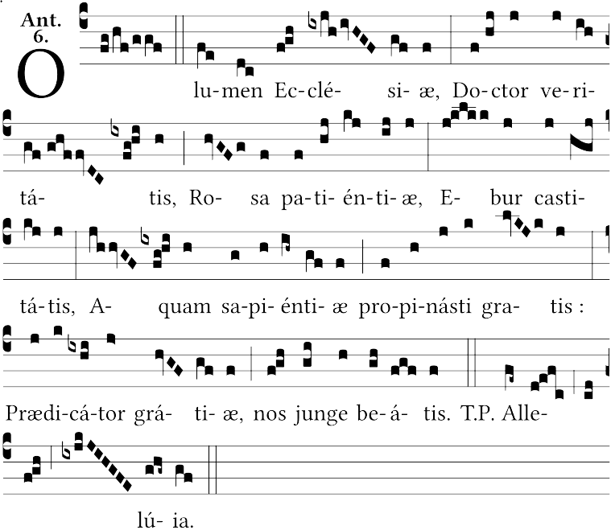
- In honour of our holy father Saint Dominic.

- In honour of Our Lady.
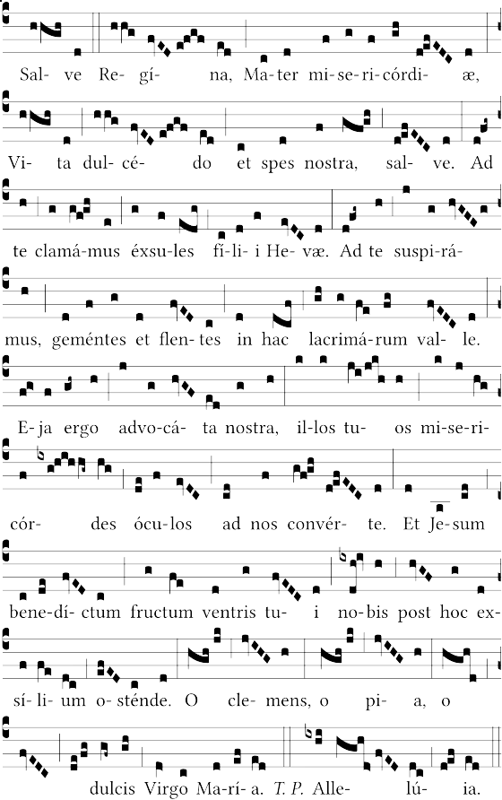

Italicised words and endings may be altered for masculine or feminine, singular or plural.

